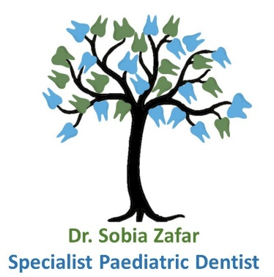**Domain:** i-carepaedsdent.com.au

**i-Care Paediatric Dentistry**

**https://i-care-one.vercel.app/**

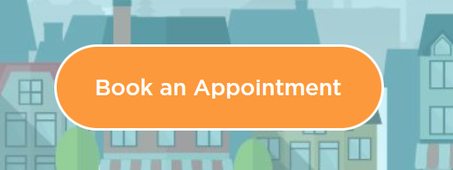

**Page 1 – HOME**

**About Us**

Welcome to **i-Care Paediatric Dentistry**

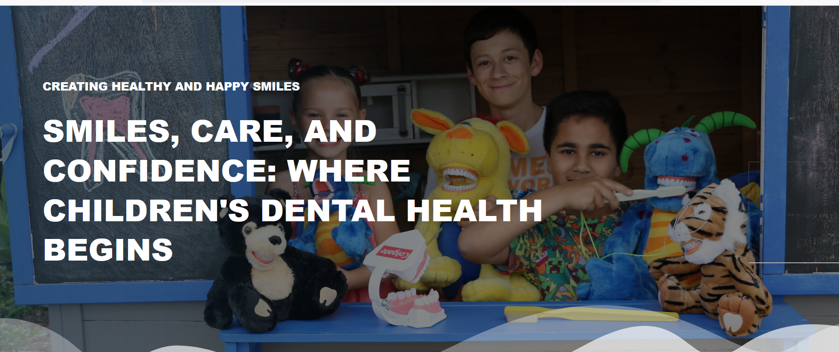

We are a registered specialist paediatric dental practice. Our specialist **A/Prof Sobia Zafar** specialise in providing dental care for children from birth through to 18 years of age. Focusing solely on children’s teeth enables us to provide high-quality, effective dental care, leading the industry in Paediatric Dentistry. Our goal is to help each child develop a healthy smile that will last a life time.

When you visit our clinic, we try to make your child feel as comfortable as possible to reduce the anxieties associated with seeing a dentist. Every aspect of our practice has been specially designed for children and their families so as to create a modern, relaxed and comfortable atmosphere.

We are proud of our staff, which is comprised of caring and dedicated professionals. They will ensure that your child’s treatment and administrative needs are met as efficiently and smoothly as possible. We generally keep to schedule to avoid any excessive waiting times.

We believe in open disclosure and encourage our patients and parents to ask questions. Where appropriate we will also provide you with additional education materials, website links and diagrams so that you fully understand your child’s dental treatment needs. Treatment options will be discussed with you as well as a detailed explanation of the most appropriate plan provided. We aim to provide you with as much information as possible so that you are equipped to make well informed decisions about your child’s dental health.

A/Prof Sobia Zafar also specialises in providing dental care to children with **complex medical conditions and disabilities**. Her practice is equipped to accommodate the diverse needs of these patients, offering a supportive and inclusive environment. The clinic is fully wheelchair-accessible, ensuring ease of access for children with mobility challenges and their families.

**We strive to provide comprehensive, compassionate dental care to all children from infancy to adolescence, including those with special health care needs.**

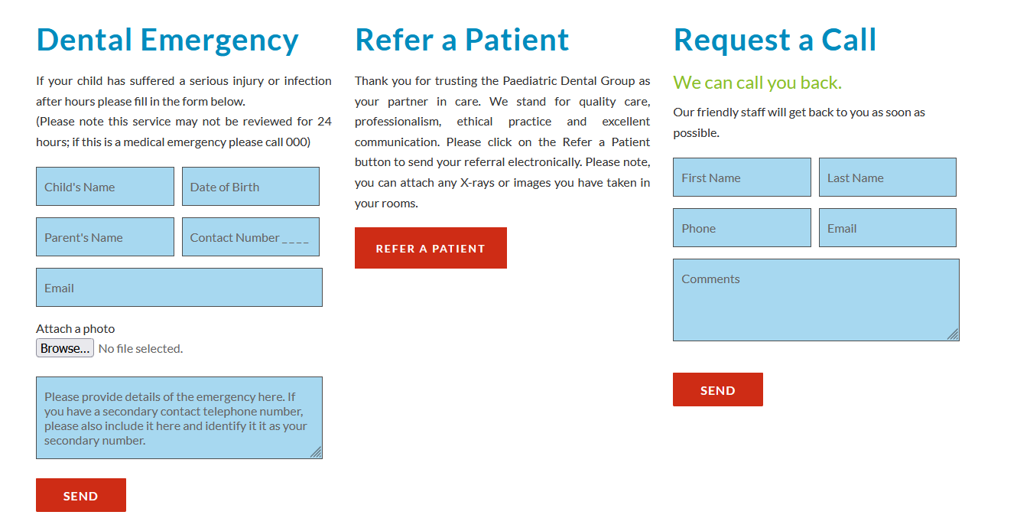

**Address:** Shop 4, 2 Centre Place

Rochedale South QLD 4123

**E-mail:** icarepaediatricdentistry@gmail.com

**Tel:** 36230000

**Map at the bottom**

**Page 2 - ABOUT US**

**Meet our Specialist Paediatric Dentist**

**Associate Professor Sobia Zafar – Specialist Paediatric Dentist**

BDS, MSc, DClinDent (Paediatric Dentistry), PhD,

FICD, FPFA, FDTFEd, SFHEA, MRACDS (Paediatric Dentistry)

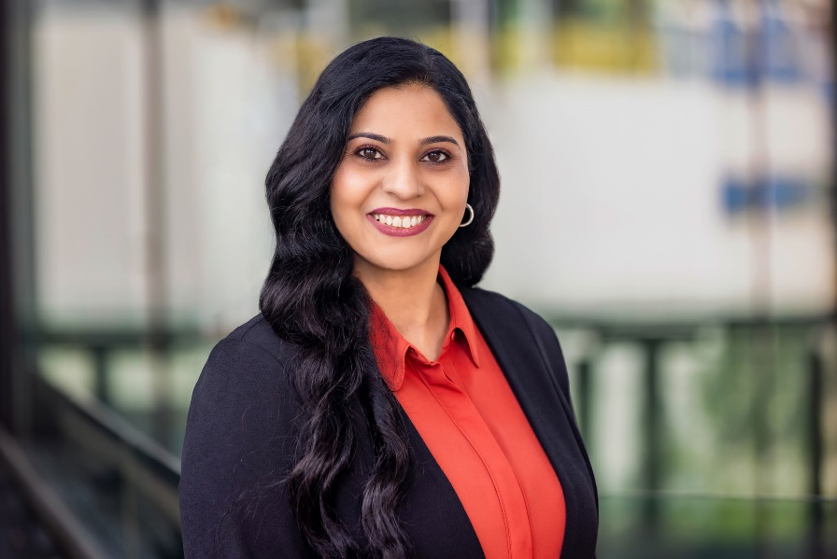A/Prof Sobia Zafar is a specialist paediatric dentist with a gentle, child-centred approach that puts children and families at the heart of every dental experience. With over 20 years of clinical and academic experience, she is renowned not only for her advanced clinical skills, but also for her genuine warmth, empathy, and unwavering commitment to children’s wellbeing.

She completed her specialist training in paediatric dentistry and Doctor of Philosophy (PhD) from the University of Otago, New Zealand. After that she worked as a specialist paeditric dentist and senior lecturer at the Oral Health Centre of Western Australia for two years. She then moved to Brisbane and is currently working as a discipline lead at the school of dentistry, The University of Queensland.

Dr Zafar understands that every child is unique, and she goes above and beyond to create a safe, welcoming, and non-judgemental environment where children feel heard, valued, and comfortable. Her calm and reassuring manner helps even the most anxious or medically complex children feel at ease, and she takes the time to build trust at every stage of care.

She has experience in treating very common to most complex paediatric dental patients. Whether treating toddlers, school-aged children, or adolescents, she tailors each visit to the child’s developmental needs, using age-appropriate communication and behaviour guidance techniques to reduce fear and build confidence. From a first dental visit to the management of dental trauma or preventive treatments, she prioritises a positive experience that fosters long-term oral health.

Dr Zafar is also deeply committed to caring for children with special needs and those from culturally and linguistically diverse (CALD) backgrounds. She is known for her inclusive, respectful, and adaptable care, and she works closely with families, support workers, and medical teams to ensure holistic, compassionate management. She regularly runs educational workshops for parents and caregivers, empowering families with the knowledge and skills to maintain their child’s oral health at home.

With A/Prof Sobia Zafar, your child is not just receiving expert dental treatment—they are being cared for with compassion, respect, and a deep commitment to their lifelong health and happiness.



**Page 3 – SERVICES**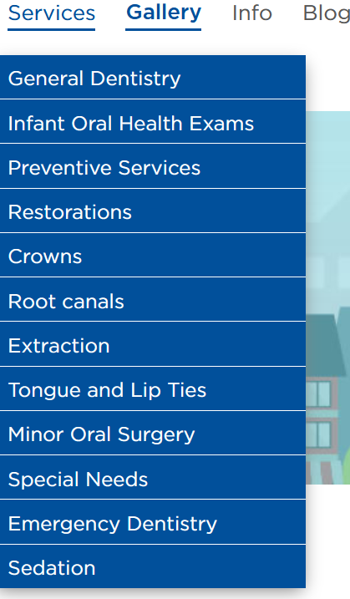 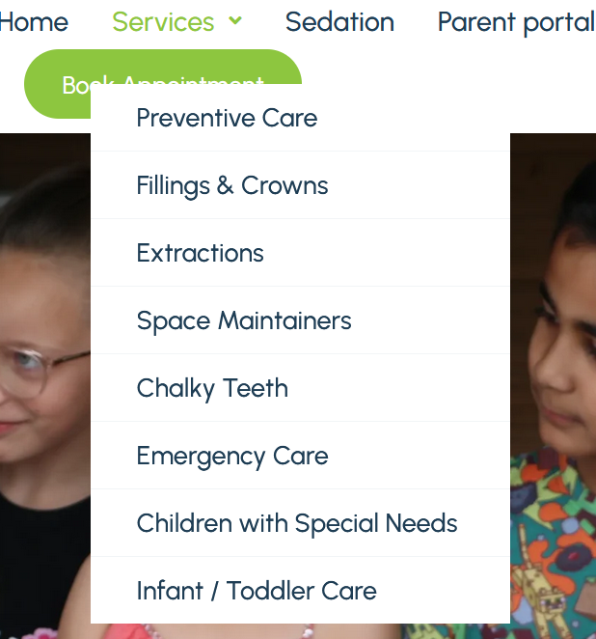

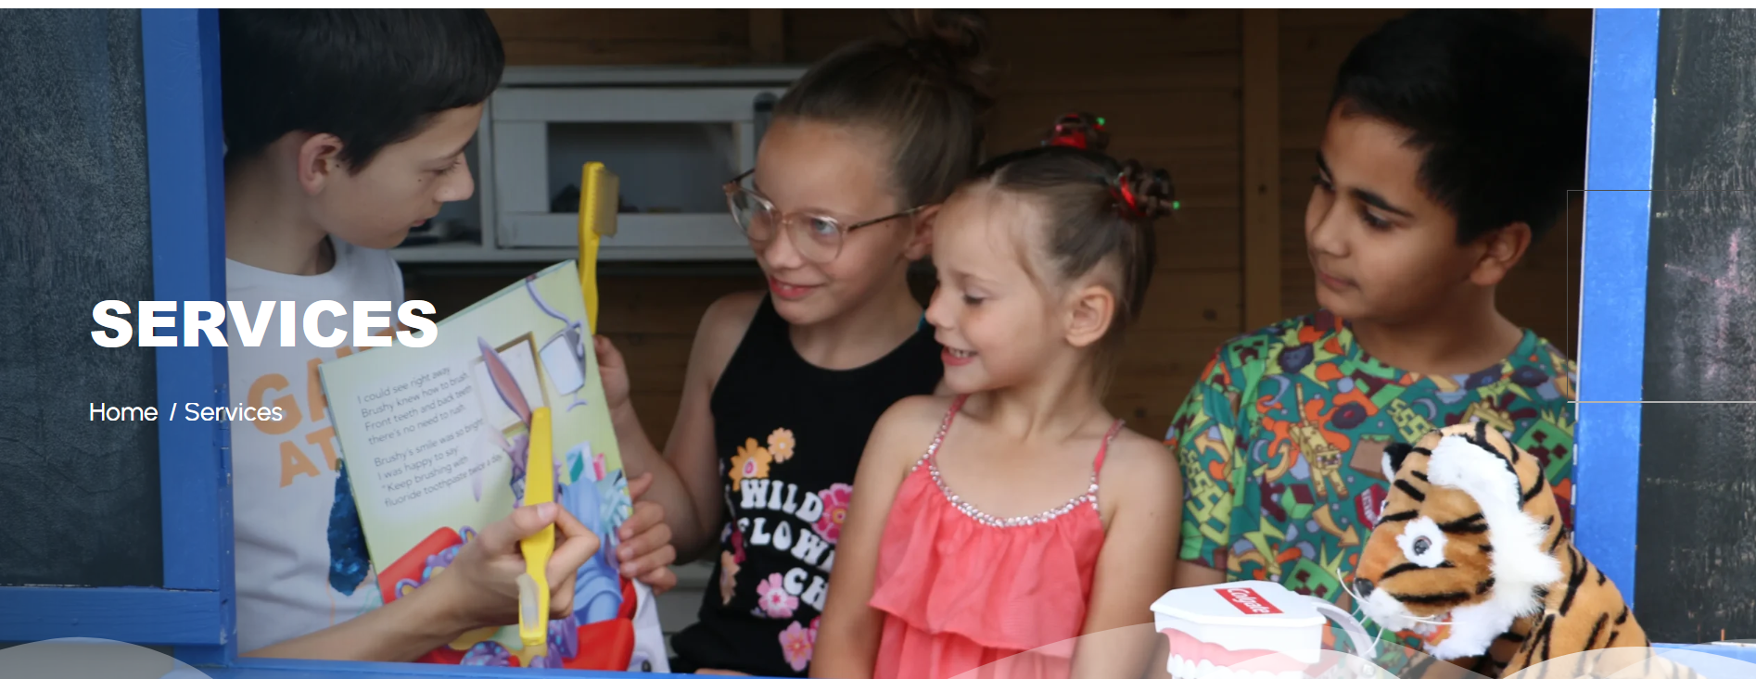

**WHAT WE DO**

**A FULL RANGE OF DENTAL SERVICES FOR KIDS OF ALL AGES**

Nurturing Healthy Smiles, One Child at a Time

We are committed to ensuring your child’s lifelong oral health, and we provide a full range of dental services to kids of all ages. Our comprehensive range of services includes general checkups, preventive care, treatment of tooth decay, composite fillings, crowns for both primary and permanent teeth, extractions, space maintainers, treatment for ‘chalky teeth’ enamel hypomineralisation, emergency care (dental trauma management), and specialised care for children with special needs.

Our goal is to provide high-quality dental care that supports healthy smiles and overall well-being from the start, ensuring children receive preventive care rather than waiting for problems to arise.

Whatever your child’s dental requirements, we’re here for them, and you.

1. **Infant/Toddler Care**

**Plz put this picture in infant care**

 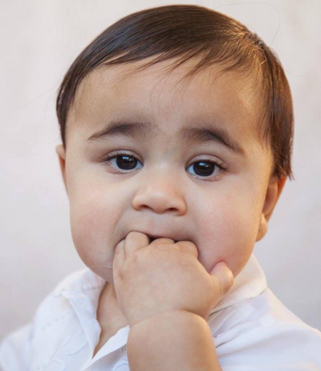 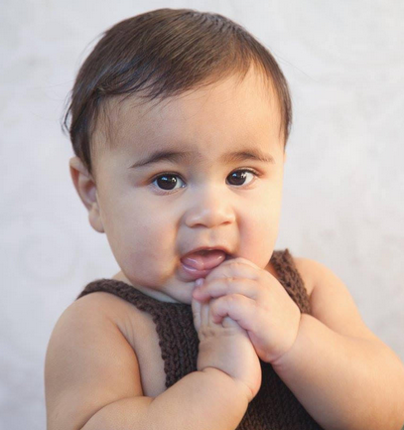

Dental Home: Where Healthy Smiles Begin

Establishing a “**DENTAL HOME”** from the start ensures continuity of care and provides a trusted point of contact in case of dental emergencies as your child begins to grow, walk, and explore.

Your Child's First Dental Visit Matters!

We focus on early prevention by welcoming infants for their first oral exam around their first birthday or within six months after their first tooth erupts. This aligned with the recommendations of the Australasian Academy of Paediatric Dentists (AAPD) and International Paediatric Bodies. Early visits ensures that your infant’s oral health is assessed early and that any necessary precautions or treatments can be initiated promptly. This also allows us to build a positive and reassuring relationship with your child while monitoring dental development.

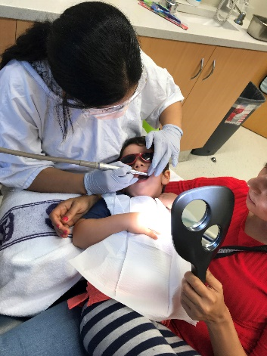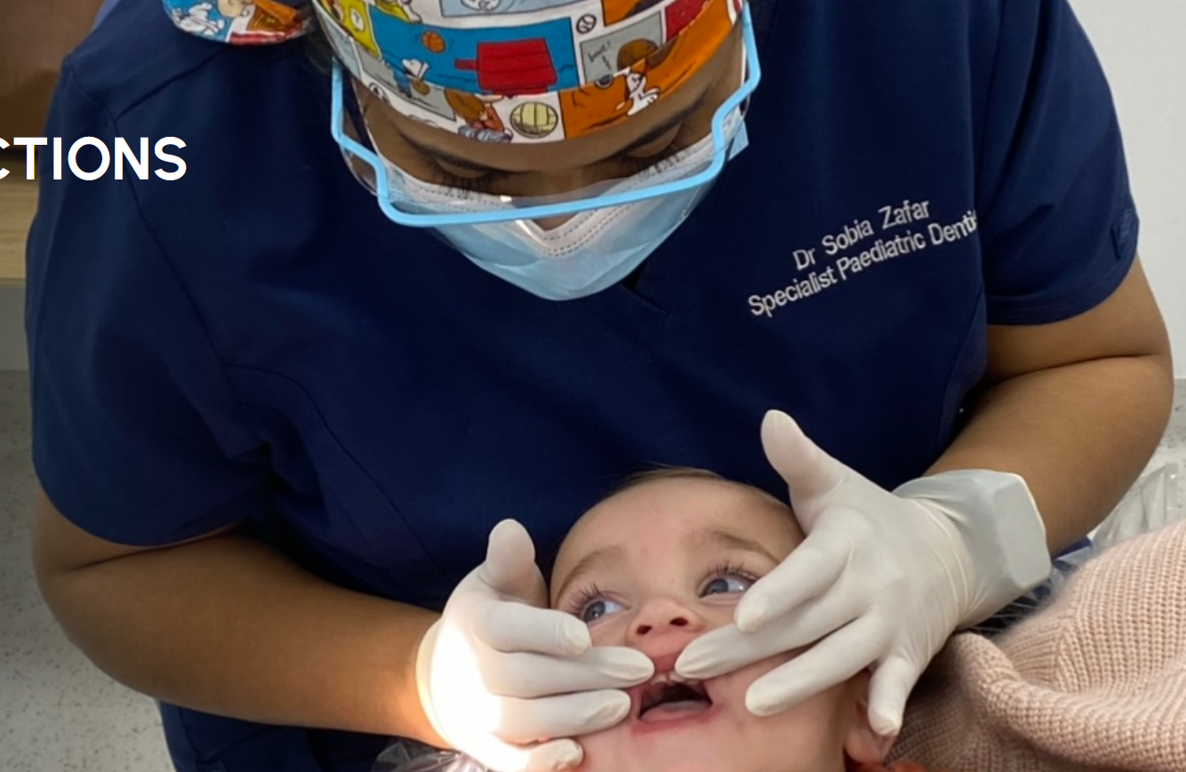

It’s also important to check 2-year olds for chalky back teeth (2-year molars). No child is “too young” to visit the dentist. Don’t wait until your child has a problem before you make a dental appointment.

1. **Preventive Care**

## Building Lifelong Smiles: Our Preventive Care Approach

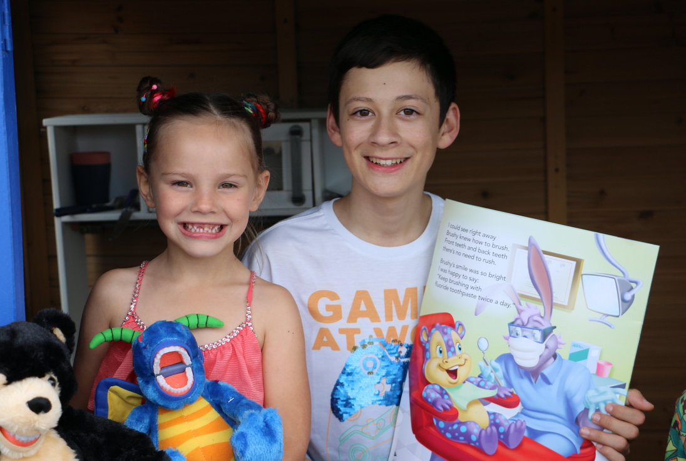

A lifetime of good dental health is set up from an early age. That’s why at **i-Care Paediatric Dentistry** we focus on prevention and early intervention. We provide the following preventive dental services:

* Regular Dental Check Ups
* Fissure Sealants
* Dental X-Rays
* Mouth Guards

1. **Fillings & Crowns**

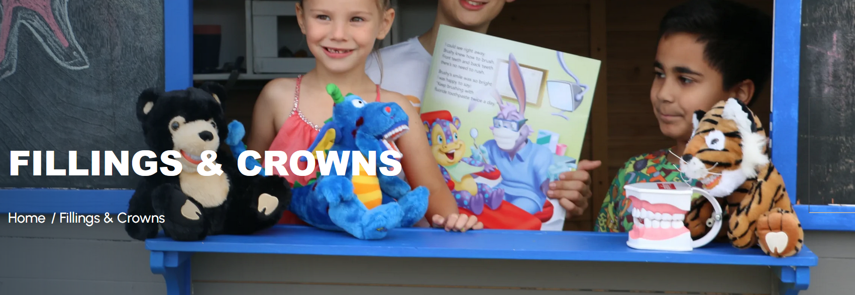

**Composite Fillings**

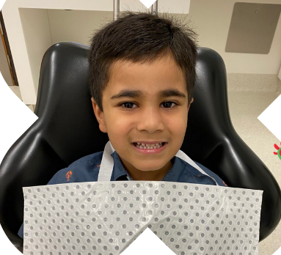A composite filling is a tooth coloured filling material that can be placed on a primary or permanent tooth. Composite fillings may be used to cover one or more surfaces, repair small fractures, minimally damaged or decayed teeth thereby restoring them to their normal colour, shape, contour and function. Composite fillings are also compatible with dental sealants, thereby allowing the dentist to complete both fillings and sealants at the same time. Composite fillings are not suitable for teeth that have had pulp (nerve) treatment or for extensively damaged teeth.

**Composite Crowns for Front Teeth**

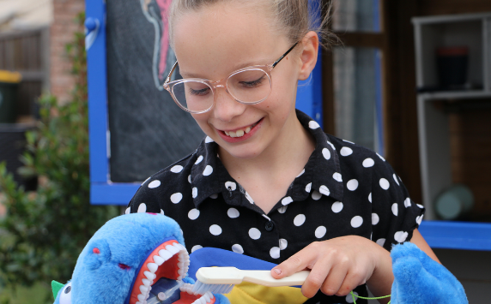Adhesive composite crowns for front teeth are used to repair a front tooth that may have been damaged by decay, malformation, discoloration or injury. Because the tooth coloured filling wraps around the entire tooth surface it is much stronger and longer lasting than normal adhesive fillings which only cover part of the tooth.

As with all adhesive restorations care should be taken to avoid sticky chewy food and also patients are advised not to bite into hard apples, carrots using front teeth as they may fracture or dislodge the filling.

**Crowns**

Crowns used to restore molar teeth can be white (Zirconia) or silver (stainless steel).

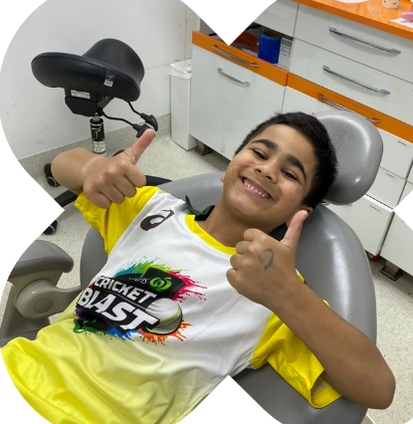Common reasons for placing a crown include:

Repairing a baby or an adult molar that is significantly decayed and has little tooth structure left to support a filling. Without the placement of a crown the remaining portion of the severely weakened tooth may decay/ fracture further and extraction may be the only option.

Repairing a baby molar following nerve treatment (pulpotomy).

Repairing a “chalky” baby molar or young adult molar that hasn’t hardened properly during its development.

The advantages of non-allergic stainless-steel crowns are that they preserve more of the tooth structure, are long lasting and easy to clean. On a young adult molar, the stainless-steel crown can act as a temporary filling and is often replaced with a porcelain crown once the child has reached adulthood.

1. **Extractions**

Ensuring Your Child's Comfort

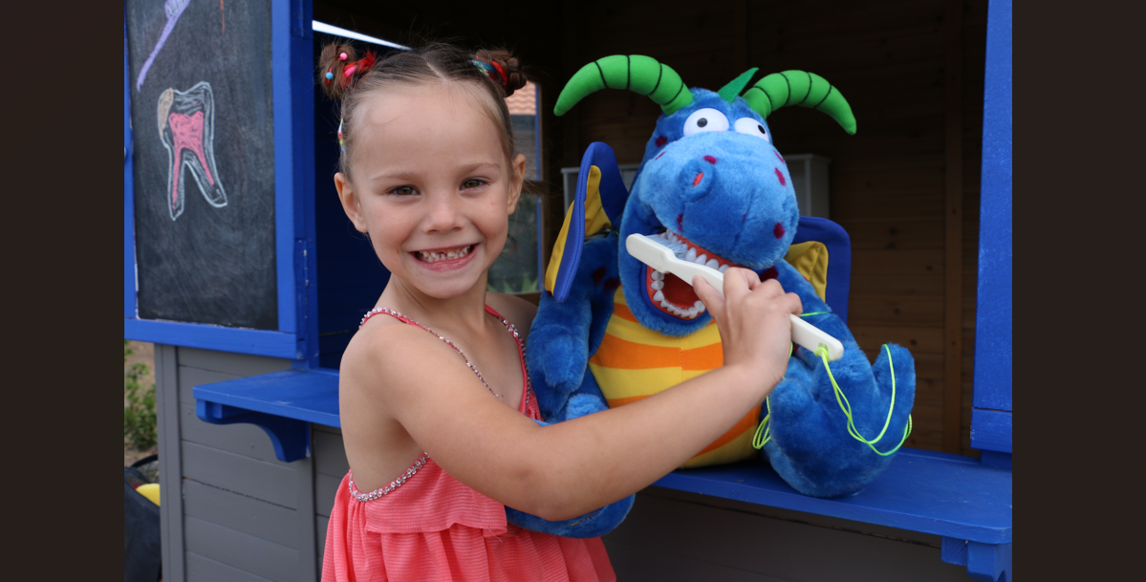

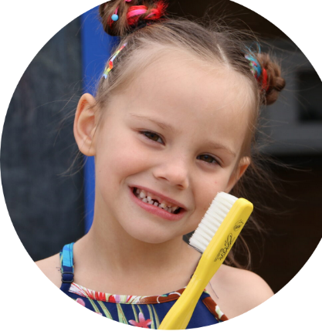Our policy at ***i-Care Paediatric Dentistry*** is to save all teeth whenever possible, but there are occasions when an extraction may be necessary. These reasons include: Extensive decay, tooth ache, abscessed teeth, severely chalky molars, and orthodontic reasons.

We also understand that the thought of tooth removal can an overwhelming experience for you and your child. A/Prof Sobia Zafar will guide you on how to best prepare your child for the procedure. If your child struggles to cooperate in the chair sedation options are also available.

1. **Space Maintainers**

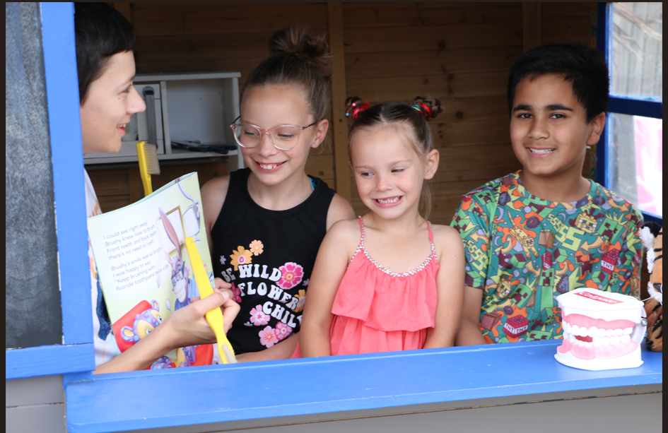

Preserving Precious Smiles

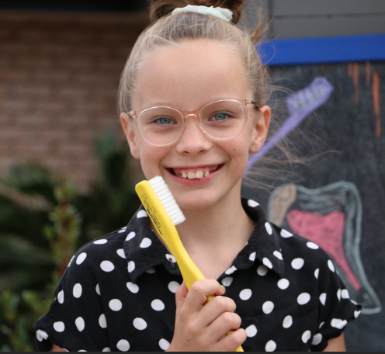Space maintainers hold the space for an unerupted adult tooth necessitated by the early loss of a baby tooth. Space maintainers are orthodontic appliances made of non-allergic stainless steel that are custom fitted and cemented to the adjacent tooth. If a baby tooth is lost early (due to infection, decay or trauma) the teeth on either side can tilt or drift thereby closing the space for the unerupted adult tooth. Failure to hold the space open may result in crowding or crooked teeth that may then warrant extensive orthodontic treatment. Some children require orthodontic treatment anyway but maintaining the space will decrease the severity of the problems. Once the permanent tooth begins to grow in the space where the baby tooth is missing the space maintainer is removed.

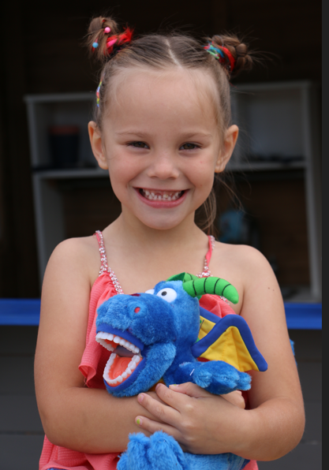Children readily adapt to space maintainers. Whilst a space maintainer is in place care should be taken to avoid sticky chewy food as this can loosen/distort the spacers and disintegrate the glue used to hold the spacer. Patients are also asked not to push on their spacer with their tongue of fingers. The spacer has to be kept clean with good brushing. Regular dental visits are recommended to monitor the eruption of the adult tooth also to ensure that the glue/cement holding the spacer has not disintegrated as this can then cause cavities to develop.

If the spacer becomes loose it is important that you arrange an appointment for your child to the dentist immediately so that the spacer can be reglued.

1. **“Chalky Teeth” Enamel Hypomineralisation**

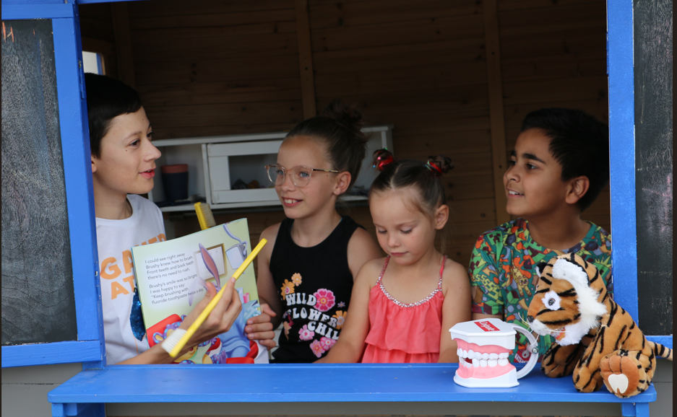

Enamel Hypomineralisation Care for a Lifetime of Healthy Teeth

It is a relatively common condition that varies in clinical severity and can result in early loss of the first permanent molars. Teeth most commonly affected are the first permanent molars (six-year-old molars) and the permanent incisors. This condition is therefore referred to as “Molar Incisor Hypomineralisation”.

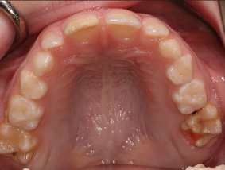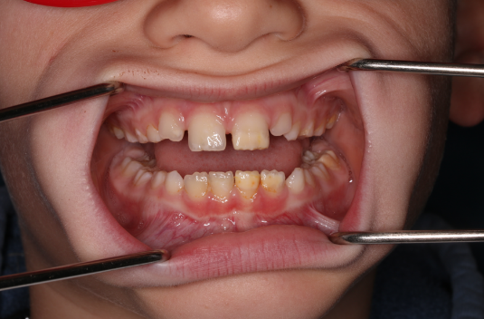

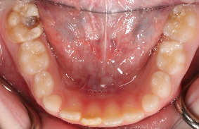Although the cause is unclear Enamel Hypomineralisation has been seen in children born preterm and in those with poor general health in the first 3 years. In addition to a number of systemic conditions, low birth weight, toxins from breast feeding and common childhood illnesses such as upper respiratory tract infections, recurrent ear infections, asthma, tonsillitis in the first 3 years have all been linked to Enamel Hypomineralisation. Degrees of Enamel Hypomineralisation range from mild colour changes in the enamel to enamel that is very sensitive and readily breaks away and is prone to large cavities as the tooth emerges in the mouth.

Defending Children's Smiles

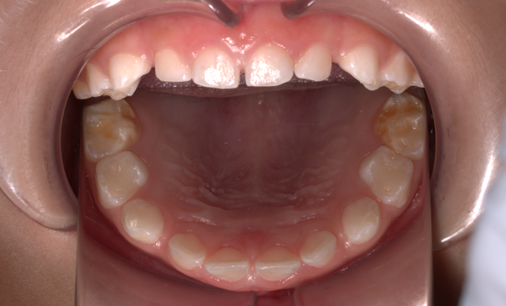Early diagnosis and management are important to ensure the best long-term outcome. If children appear to have this condition on their baby molars (usually detected between 2-5 years of age) there is an increased likelihood of Enamel Hypomineralisation also affecting the first permanent molars and permanent incisor teeth as they teeth develop around the same time.

Treatment depends on the severity and the teeth that are affected.

Permanent molars affected by Enamel Hypomineralisation require early intervention.

1. **Emergency Care**

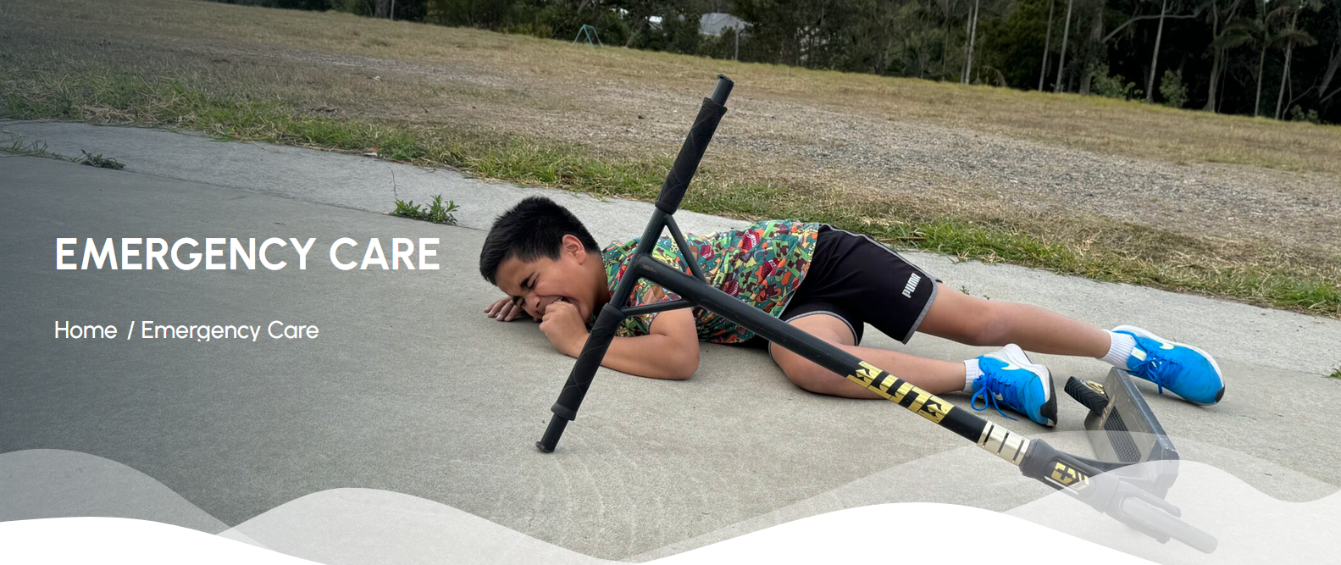

At **i-Care Paediatric Dentistry** we understand that no parent ever wants to see their child in distress. If your child has dental pain, dental injuries or a facial swelling from a dental infection please contact our rooms and we will address this as a priority and offer you an appointment ASAP.

**Tooth Ache**

The most common cause of tooth ache is tooth decay. Other causes of toothache include chalky teeth, tooth fractures and dental trauma.

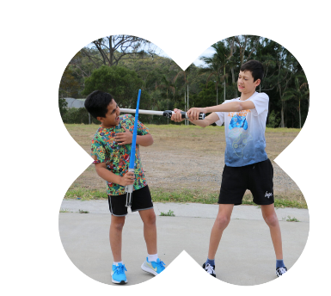

Impacted food can cause pain in young children and can be removed using a soft tooth brush or dental floss. If pain persists please contact us to arrange an appointment.

If your child’s symptoms include throbbing, pain, fever, malaise it is imperative to seek emergency care immediately. After hours emergencies can be managed by seeking care at your local hospital emergency department or through the Queensland Children’s hospital.

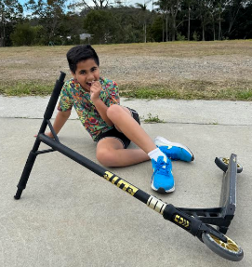

**Dental Trauma**

It is important that all dental trauma be assessed immediately by a dentist. General advice following dental trauma-Complete the course of antibiotics if prescribed and maintain a soft diet for 1-2 weeks. Brush with a soft tooth brush after every meal and if chlorhexidine has been recommended use this instead of tooth paste for the next week.

1. **Children with Special Needs**

Special Kids, Special Smiles: Special Care for Every Child’s Unique Needs

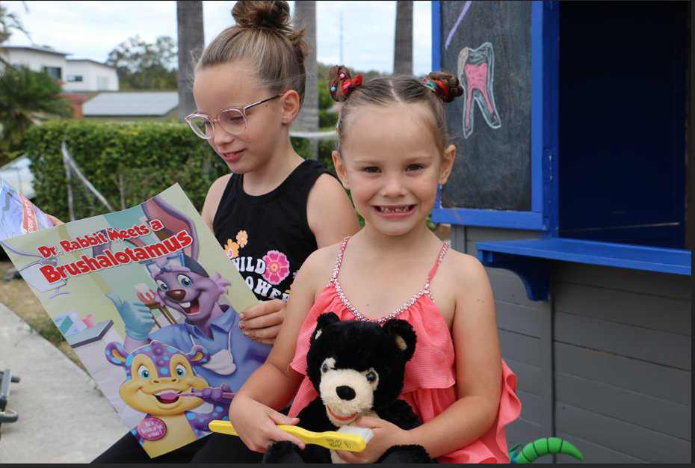

We welcome all patients with special needs including children with autism, Down’s syndrome, visual or hearing impairment and many other conditions that make standard dental procedures difficult.

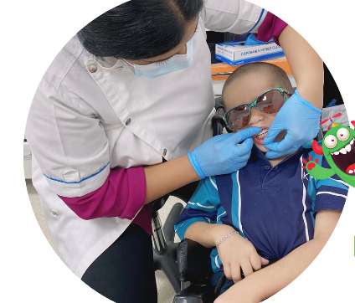Children with special needs are almost twice as likely to have unmet dental problems compared to children without special needs.

We understand that maintaining the oral Health of children with special needs can be challenging. We also recognise that chalky teeth problems are more common in children who have experienced medical issues during childhood.

A/Prof Sobia Zafar has had extensive experience in the management and treatment of patients with special needs.

**Page 3**

**Sedation**

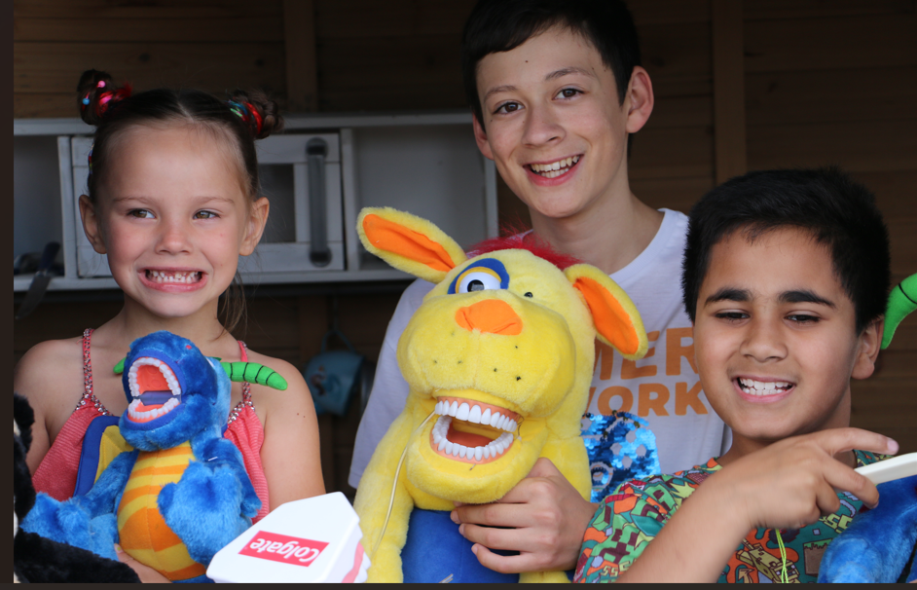

Sedation Dentistry refers to the use of sedation during dental treatment. At ***i-Care Paediatric Dentistry***, we understand that young children and some older children might find dental treatment quite difficult to cope with. We offer treatment using Nitrous Oxide sedation and treatment under General Aesthetic (at the St Andrews War Memorial Day Hospital). Some of the questions that need to be asked prior to deciding if sedation is required for your child include:

* Is your child old enough to cope with treatment in the chair?
* What was their previous dental history?
* Does your child require complex dental treatment?
* How long can your child sit still in the chair?
* How long can your child keep their mouth open?
* Is your child able to tolerate local anaesthetic?
* Does your child have a strong gag reflex?
* How many teeth need treatment
* Which option allows for the highest standard of treatment?

1. **Nitrous Oxide Sedation (Laughing Gas)**

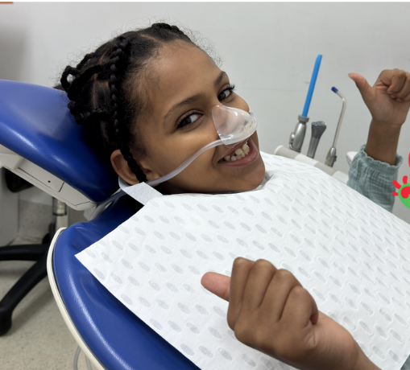Nitrous oxide also known as Laughing gas is a form of sedation that is particularly useful to alleviate anxiety in older children for simple procedures of short duration. A certain degree of patient co-operation is required for this technique to be successful.

Using a special mask that fits over the nose, your child will inhale nitrous oxide. The gas will begin to work within a few minutes and often gives a relaxed feeling. Nitrous oxide is effective, safe, and the effects are reversed quickly at the completion of treatment.

1. **General Anaesthesia**

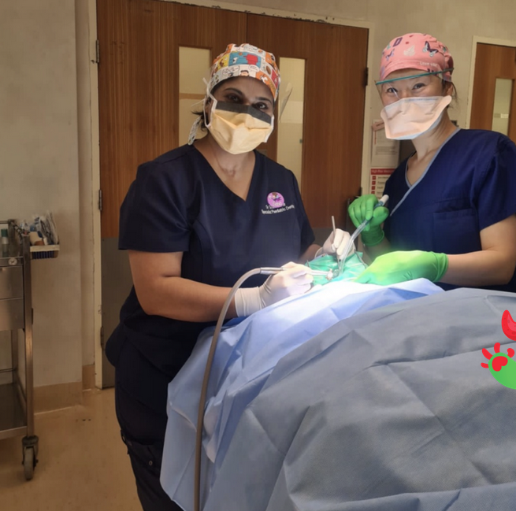If your child is young, anxious, requires extensive or complex dental treatment, has special needs and has a strong gag reflex, treatment under general anaesthetic should be considered.

General anaesthesia means that your child is fully asleep. This approach of treatment allows all treatment and x-rays to be completed in one appointment, where 4-5 appointments with local anaesthetic/nitrous oxide may be required in the dental surgery.

The average time taken for comprehensive treatment under GA is around 1.5 hours. This mode of treatment will minimise your child having a negative experience and developing dental phobias. Many adults that are anxious about dental treatment usually have had a negative childhood experience. Children have a lifetime of dental visits to come!

Dental treatment under general anaesthetic is performed by A/Prof Sobia Zafar at the St Andrews War Memorial Hospital, where A/Prof Sobia Zafar is fully registered and accredited as a specialist paediatric dentist. The general anaesthetic is administered by a member of our team of highly qualified specialist anaesthetists with years of experience in paediatric care. You can be rest assured your child will be well looked after. Please contact our rooms should you require more information regarding our anaesthetic team.

Following the initial consultation A/Prof Zafar will give you a comprehensive report along with a detailed dental treatment plan (with health fund item numbers), anaesthetic fees and hospital fees. All attempts are made to provide an accurate assessment of the anticipated treatment costs.

**Treatment Plan**

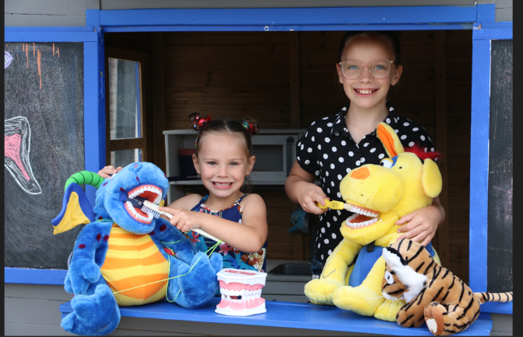At the initial comprehensive consultation, you will be provided with a treatment plan estimate (with health fund item numbers). Please be aware that the treatment is an estimate only and can vary depending on what is found at the time of the general anaesthetic. If radiographs are to be taken at the time of the surgery, a change in the treatment plan is more likely. If extra payment is required due to a change in the treatment plan, this is due on the following business day following your child's surgery. If we do less treatment than expected, you will be reimbursed the difference in cost.

If your child requires treatment under general anaesthetic, our staff will go through the required paperwork, including information sheet, consents, and information about where and when the surgery will be undertaken.

**Booking your child's theatre date**

To book your child's spot at hospital, a non-refundable $300 deposit is taken. This is payable via credit card in person or over the phone, as well as via Direct Debit.

The remaining Dental Treatment Fee is payable 07 days prior to surgery. If your child becomes unwell, please let us know immediately, and we can organise to reschedule your child's theatre date. If the full payment is not received 07 days prior to surgery, your child's theatre date will be rescheduled even if the $300 deposit has been paid.

**General Anaesthetic Fees**

Treatment under general anaesthetic will incur three main costs:

1) Dental Treatment Fee (payable directly to i-Care Paediatric Dentistry)

2) Hospital Fee (payable directly to the hospital)

3) Anaesthetist Fee (payable directly to the anaesthetic group)

You will be provided with the contact details for the hospital as well as the anaesthetic group. Please get in touch with the hospital and the anaesthetic groups directly to confirm fees payable. The hospital and anaesthetic fees are payable prior to surgery.

**Private Health Insurance**

If your child holds private health insurance, please get in touch with your health fund if you would like to know how much they will reimburse. Your child's treatment plan has the codes you need to provide to your health fund e.g. 022, 111, 121.

'Extras' will pay towards the dental treatment and 'Hospital' will contribute towards the hospital fee.

Some health funds do not charge an excess when children are admitted to hospital, so it is worth checking with your health fund.

Once your child has had the dental treatment completed, an invoice will be emailed to you. You can then use this invoice to claim your rebate through your health fund.

**Child Dental Benefit Schedule (CDBS)**

Unfortunately the CDBS scheme does not contribute towards any dental treatment undertaken at the hospital.

**Questions?**

Going to hospital with your child can be a stressful and overwhelming process. We hope to make it as easy and straightforward as possible. If you have any questions at all, please do not hesitate to get in touch with us either via phone (07) [3343 3322](mailto:3343%203322) or email [paedsdentga@gmail.com](mailto:paedsdentga@gmail.com)

Page 4 -

**Parent portal**

* Referrals

Link: <https://www.prosthocare.com.au/patient-referral-1>

Link: <https://dentalpx.com.au/referrals/>

* Information
* Contact us

Page 5 –

* Gallery
* Research
* Publications
* Grants
* Awards
* Media
* Testimonials